**TRƯỜNG THCS PHAN CÔNG HỚN**

**TỔ TIẾNG ANH - TIẾNG ANH 9**

**TUẦN 25 (TỪ 3/3 ĐẾN 8 /3)**

**WEEK 25**

**PERIOD 73-74-75**

**UNIT 6: NATURAL WONDERS _ REVIEW**

**TEST – UNIT 6**

***I. Listen to the record player three times, then choose the best answer (A, B, C or D). (1pt)***

***(Từ câu 1 đến câu 4, thí sinh chỉ viết mẫu tự (A, B, C hoặc D) đại diện cho câu trả lời đúng vào Phần ANSWERS) (Track 12-p35-WB)***

**1.**

**2.**

**3.**

**4.**

**ANSWERS**

1. Harry has just come back from____________

A. Richmond Lake B. Great Lake C. Loch Ness Lake D. Victoria Lake

2. Gina thinks the rangers should consider asking people to_______________

A. stop talking B. turn down the music C. turn up the music D. spoiling the area

3. If people keep_________________, no one will want to go to the Lake anymore

A. singing B. hunting C. climbing D. littering

4. The rangers put up a________________ to stop people climbing the rocks

A. sign B. tent C. silence D. scene

***II. Choose the word or phrase (A, B, C or D) that best fits the space or best answers the question given in each sentence. (2.5 pts)***

***(Từ câu 5 đến câu 14, thí sinh chỉ viết mẫu tự (A, B, C hoặc D) đại diện cho câu trả lời đúng vào Phần ANSWERS)***

**5.**

**6.**

**7.**

**8.**

**9.**

**10.**

**11.**

**12.**

**13.**

**14.**

**ANSWERS**

5. Which word has the underlined part pronounced differently from that of the others?

A. change B. choose C. chore D. chorus

6. Which word has the underlined part pronounced differently from that of the others?

A. commercial B. benefit C. impressive D. festival

7. Which word has a different stress pattern from that of the others?

A. comfortable B. dangerous C. difficult D. believable

8. Which word has a different stress pattern from that of the others?

A. expensive B. interesting C. challenging D. beautiful

9. The ________________of the mountain is the highest point or peak of the mountain.

A. view B. summit C. bottom D. scene

10. People need to stop____________________ wild animals

A. hunt B. hunting C. to hunting D. to hunt

11. The [oil](https://dictionary.cambridge.org/dictionary/english/oil) [spill](https://dictionary.cambridge.org/dictionary/english/spill) has _____________the [whole](https://dictionary.cambridge.org/dictionary/english/whole) [beautiful](https://dictionary.cambridge.org/dictionary/english/beautiful) [coastline](https://dictionary.cambridge.org/dictionary/english/coastline)

A. fined B. disturbed C.spoiled D. considered

12. The next hotel we tried was ______________ expensive than the first one*.*

A. most more B.many more C.much more D. the most

13. Kami Rita Sherpa,_______________ is 52 years old, has climbed MT Everest more than anyone.

A. when B.who C.which D. that

14. “You must visit our place sometime.” - “________”

A. Yes, I love travelling. B. Sorry. I’m busy tonight. C.No, thanks. I’m good. D. Yes, I will.

***III. Look at the signs. Choose the best answer (A, B, C or D) for questions 15 and 16. (0.5pt)***

***(Từ câu 15 đến câu 16, thí sinh chỉ viết mẫu tự (A, B, C hoặc D) đại diện cho câu trả lời đúng vào Phần ANSWERS)***

**16.**

**15.**

**ANSWERS**

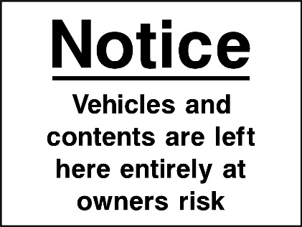15.What does the sign mean?

A. Your car is safe here but you are not

B. Your car and personal processions may not be safe here

C. You should not leave the car window opens

D. You should leave your car and belongings at home.

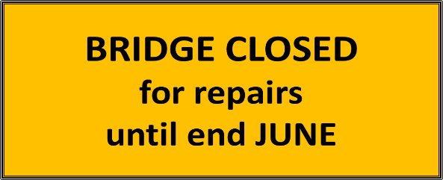16. What does the sign say?

A.Repairs to the bridge will start at the end of June

B.You can only use the bridge until June

C. From July on, you can drive across the bridge

D. You can use the bridge from now to June.

***IV.* *Choose the word (A, B, C or D) that best fits the space in the following passage. (1.5 pts)***

Da Lat – Dream City Da Lat lies on Lam Vien plateau, in the Central Highland province of

**17.**

**18.**

**19.**

**20.**

**21.**

**22.**

**ANSWERS**

Lam Dong, 300 kilometres north of Ho Chi Minh City. Da Lat is a well-known city (17) _______

all the people who have been there once. Da Lat is known as a city of pine trees, waterfalls and

flowers. Da Lat is described (18)______ a forest of flowers with different colours and

(19)______ species. Flowers can be found anywhere and in any season. Da Lat has the widest

range of orchid varieties in the country. Da Lat has (20) _______ rivers and canals but it has

many picturesque waterfalls. It takes tourists several days (21 ) ____ all the waterfalls in the area.

The famous Cam Ly Falls is only 3 kilometres from the town centre. The Prenn Falls is 10 kilometres

in the south of Da Lat. The water (22) ______ down like a white shade. Da Lat people are very proud

of it. They always boast to tourists about it in the first place. Around the Prenn Falls is the valley

of various flowers and pine hills.

17. A. considering B. attracting C.suggesting D. believing

18. A. in B. on C. as D. from

19. A. various B. variety C.vary D. varying

20. A. lots of B. many C. few D. little

21. A. visit B. visiting C. to visit D. visited

22. A. goes B. pours C. walks D. circles

***V*. *Read the following passage. Decide if the statements from 23 to 26 are True or False and choose the correct answer (A, B, C or D) for the questions 27 and 28*. *(1.5 pts)***

The Mekong Delta in Southwestern of Viet Nam is a really beautiful place and one of the most

**captivating** spots in Southeast Asia. It has lots of winding canals and rivers that create a special maze

for exploring. When you go there, you'll see lots of green plants and trees along the water, which makes

it feel magical and different from other places.Compared to other pretty areas in Viet Nam like Sa Pa or

Da Lat, the Mekong Delta has its own special appeal. Instead of mountains or charming landscapes, it's

known for having big fields where they grow lots of rice and fruit. The land is flat and the Mekong River

flows calmly, making it a beautiful sight to see. Unlike busy cities like Hanoi or Ho Chi Minh City,

the Mekong Delta is a peaceful and quiet place. It has calm waterways and a countryside that's not busy

or noisy. It's a chance to relax, enjoy nature, and be part of a community. There are also floating markets

where people sell things from boats, which is a unique sight you won't find in cities.

**23.**

**24.**

**25.**

**26.**

**27.**

**28.**

**ANSWERS**

Overall, the Mekong Delta is a really special place with its winding canals, beautiful landscapes,

and peaceful atmosphere. Exploring it lets you experience a different side of Vietnam's natural

beauty and culture. You'll have unforgettable memories that you'll treasure for a long time.

23. MeKong Delta is located in the southwestern of Việt Nam.

24. Mekong Delta is famous for its waterfall and mountainous landscapes.

25. You can see lots of floating markets in the cities except MeKong Delta.

26**.** A visit to Mekong Delta will be an unforgettable experience.

27.Unlike Ha Noi or Ho Chí Minh, Mekong Detal is a_____________place

A. busy and bustling B. annyoing C.peaceful and quiet D. noisy

28. The word “ **captivating**” in line 1 closet meaning to_____________

A. disgusting B. attractive C.terrible D. memorable

***VI. Use the correct form of the word given in each sentence. ( 1.5 pts)***

29. The resort is easily_______________ by raod, rail and air. (access)

30. The [advanced](https://dictionary.cambridge.org/dictionary/english/advanced) [course](https://dictionary.cambridge.org/dictionary/english/course) is _______ to those who have already taken the [introductory](https://dictionary.cambridge.org/dictionary/english/introductory) [cours](https://dictionary.cambridge.org/dictionary/english/course)e. (limit)

31. In Sơn Đoong Cave, water moving down for millions of years created amazing rock__________(form)

32**.** At [night](https://dictionary.cambridge.org/dictionary/english/night), the [city](https://dictionary.cambridge.org/dictionary/english/city) is ______________ [lit](https://dictionary.cambridge.org/dictionary/english/lit) (spectacle)

33. If tourists keep_______________ the trees, the animals will leave the parks. (damage)

34. The___________for new [sources](https://dictionary.cambridge.org/dictionary/english/source) of [energy](https://dictionary.cambridge.org/dictionary/english/energy) is essential for the [future](https://dictionary.cambridge.org/dictionary/english/future) of [our](https://dictionary.cambridge.org/dictionary/english/our) [planet](https://dictionary.cambridge.org/dictionary/english/planet). (explore)

**29.**______________ **30.**______________ **31.**______________

**ANSWERS**

**32.**______________  **33.**______________  **34.**______________

***VI. Look at the entry of the word “visit” in a dictionary. Use what you can get from the entry to complete the sentences with two or three words(0.5pt)***

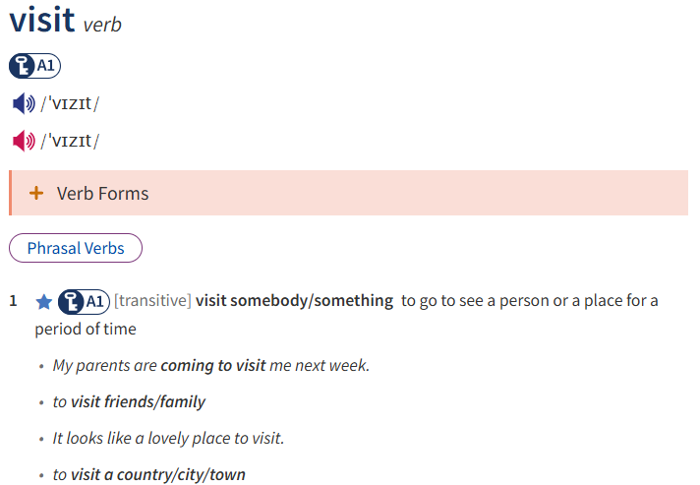

35. I have lived far from my parents for 3 years and I am ______________ them this month.

36. Many tourists want to______________ as Hồ Chí Minh.

***VIII. Rewrite the sentences***

37. We like to do the gardening on the weekend.

🡪 We are

38. My old shoes are a lot more comfortable than these new shoes

🡪These new shoes are not

39. You shouldn’t feed the animals in the zoo without the permission

🡪I suggest

40. I have just bought these new books. They were published last week. (Using relative clause)

🡪 I have just

**UNIT 7: URBAN LIFE**

**LESSON 1.1 (NEW WORDS + READING)**

1. **New words:**

- accident (n) /ˈæksɪdənt/ tai nạn

- ban (v) /bæn/ cấm

- crosswalk (n) /ˈkrɒswɔːk/ lối qua đường, chỗ băng qua đường

- encourage (v) /ɪnˈkɜːrɪdʒ/ khuyến khích

- involve (v) /ɪnˈvɑːlv/ liên quan đến

- pedestrian (n) /pəˈdestriən/ người đi bộ

- sidewalk (n) /ˈsaɪdwɔːk/ vỉa hè

- struggle (v) /ˈstrʌɡl/ đấu tranh, gắng sức

- traffic jam (n) /ˈtræfɪk dʒæm/ sự kẹt xe

- create (v) /kriˈeɪt/ tạo nên

- solution (n) /səˈluːʃn/ giải pháp, cách giải quyết

- reduce (v) /rɪˈdjuːs/ giảm

- vehicle (n) /ˈviːəkl/ xe cộ

- install (v) /ɪnˈstɔːl/ lắp đặt

1. **Match each word with the correct definition:**

|  |  |
| --- | --- |
| 1. traffic jam | A.to [experience](https://dictionary.cambridge.org/vi/dictionary/english/experience) [difficulty](https://dictionary.cambridge.org/vi/dictionary/english/difficulty) and make a very [great](https://dictionary.cambridge.org/vi/dictionary/english/great) [effort](https://dictionary.cambridge.org/vi/dictionary/english/effort) in [order](https://dictionary.cambridge.org/vi/dictionary/english/order) to do something |
| 1. struggle | B. a [place](https://dictionary.cambridge.org/vi/dictionary/english/place) on a [road](https://dictionary.cambridge.org/vi/dictionary/english/road), [especially](https://dictionary.cambridge.org/vi/dictionary/english/especially) one where there is a lot of [traffic](https://dictionary.cambridge.org/vi/dictionary/english/traffic), at which [vehicles](https://dictionary.cambridge.org/vi/dictionary/english/vehicle) must [stop](https://dictionary.cambridge.org/vi/dictionary/english/stop) to [allow](https://dictionary.cambridge.org/vi/dictionary/english/allow) [people](https://dictionary.cambridge.org/vi/dictionary/english/people) to [walk](https://dictionary.cambridge.org/vi/dictionary/english/walk) [across](https://dictionary.cambridge.org/vi/dictionary/english/across) the [road](https://dictionary.cambridge.org/vi/dictionary/english/road) |
| 1. sidewalk | 1. something [bad](https://dictionary.cambridge.org/vi/dictionary/english/bad) that [happens](https://dictionary.cambridge.org/vi/dictionary/english/happen) that is not [expected](https://dictionary.cambridge.org/vi/dictionary/english/expected) or [intended](https://dictionary.cambridge.org/vi/dictionary/english/intended) and that often [damages](https://dictionary.cambridge.org/vi/dictionary/english/damages) something or [injures](https://dictionary.cambridge.org/vi/dictionary/english/injure) someone |
| 1. crosswalk | D. a [large](https://dictionary.cambridge.org/vi/dictionary/english/large) [number](https://dictionary.cambridge.org/vi/dictionary/english/number) of [vehicles](https://dictionary.cambridge.org/vi/dictionary/english/vehicle) [close](https://dictionary.cambridge.org/vi/dictionary/english/close) together and [unable](https://dictionary.cambridge.org/vi/dictionary/english/unable) to [move](https://dictionary.cambridge.org/vi/dictionary/english/move) or [moving](https://dictionary.cambridge.org/vi/dictionary/english/moving) very [slowly](https://dictionary.cambridge.org/vi/dictionary/english/slow) |
| 1. pedestrian | E.a [path](https://dictionary.cambridge.org/vi/dictionary/english/path) with a hard [surface](https://dictionary.cambridge.org/vi/dictionary/english/surface) on one or both [sides](https://dictionary.cambridge.org/vi/dictionary/english/side) of a [road](https://dictionary.cambridge.org/vi/dictionary/english/road), that [people](https://dictionary.cambridge.org/vi/dictionary/english/people) [walk](https://dictionary.cambridge.org/vi/dictionary/english/walk) on |
| 1. accident | 1. a [person](https://dictionary.cambridge.org/vi/dictionary/english/person) who is [walking](https://dictionary.cambridge.org/vi/dictionary/english/walking), [especially](https://dictionary.cambridge.org/vi/dictionary/english/especially) in an [area](https://dictionary.cambridge.org/vi/dictionary/english/area) where [vehicles](https://dictionary.cambridge.org/vi/dictionary/english/vehicle) go |

1. **Choose the correct options:**
2. I would often jog along the **sidewalk/ crosswalk** in our neighborhood in the morning.
3. Some people form rural areas often **struggle/ encourage** to find affordable houses in the city.
4. The city is trying to improve the **crosswalks/ pedestrians** so that drivers can see them better.
5. To reduce traffic jams, the city decided to **involve/ ban** certain type of vehicles traveling into the city center during specific hours.
6. The sudden heavy rain caused a(n) **traffic jam/ accident** in the area for two hours.
7. **Choose the best answers:**
8. The city has to build more crosswalks because of the increase in the number of __________. (accidents/ pedestrians/ sidewalks/ animals)
9. What can we do to __________ people to use public transportation more. (struggle/ encourage/ install/ involve)
10. We agree with the __________ on the use of mobile phones when driving on the streets. (vehicle/ ban/ solution/ sidewalk)
11. The _________ got hit by a car while he was crossing the street. (council/ pedestrian/ worker/ general)
12. I __________ home when I saw some tourists struggling to cross the street. (am walking/ was walking/ were walking/ is walking)
13. If we lower the cost of the subway, it will encourage people __________ public transportation. (use/ useful/ to use/ used)
14. People were crossing the street unsafely, and that caused ___________ . (traffic jam/ accidents/ attractions/ tourist)
15. To ___________ these dangers, the city council made rules to stop cars from driving some streets at certain times. (ban/ reduce/ install/ create)
16. There are so many more cars on the streets now that there are __________ everyday. (sidewalks/ crosswalks/ traffic jams/ accident)
17. I was walking __________ the sidewalk when I met Kevin. (in/ on/ at/ of)
18. **Choose the word (A, B,C or D) that best fits the space in the following passages.**

In the past, there were major safety issues for pedestrians in the town where I lived. (1)__________ people found it challenging to walk and cross the street without fear. In some areas, there weren’t enough sidewalks and crosswalks, which made it very dangerous for people (2)__________ around the town. To reduce these dangers, the city council made rules to stop cars from driving some streets at certain times. These rules improves these areas for pedestrian (3)__________ they didn’t have to worry about getting hit by a car while they (4)__________ the local council also planned to build more sidewalks and crosswalks throughout (5)__________ whole town with the aim of providing pedestrians with clear pathways and safe crossing points, thereby enhancing overall safety.

1. A. Much B. Little C. Many D. A little
2. A. walk B. walked C. to walk D. to walking
3. A. but B. still C. however D. because
4. A. walk B. walks C. are walking D. were walking
5. A. Ø B. the C. an D. a